ORGANIZING COMMITTEE:

Chairperson:
O.O. Novomlynets, D.Sc. (Tech.), Professor, Honored Worker of Education of Ukraine, Rector of the Chernihiv Polytechnic National University.

Vice Chairperson:
A. L. Prystupa, Ph.D. (Techn.), Associate Professor, vice-rector for scientific work of the Chernihiv Polytechnic National University
Zh.V. Derii, D.Sc. (Econ.), Professor, Head of the Department of Economics, Accounting, and Taxation

Members of the Organizing Committee:
Cristina Gabriela Cosmulese, PhD, Department of Accounting, Audit and Finance, Ştefan cel Mare University of Suceava
Rafał Dymczyk, Dr. hab., Prof., Head of the Center for Philippine Studies, Head of Laboratory of Humanistic Interdisciplinary Studies, Program Council of Inter-Area Individual Studies in the Humanities (MISH), Adam Mickiewicz University, Poznan
Nadiia Reznik, Dr. Prof. UNIWERSYTET JUTRA II - zintegrowany program rozwoju Uniwersytetu im. Adama Mickiewicza w Poznaniu, Polska
Jan-Urban Sandal, Dr. Prof., founder and owner of Fil. Dr. Jan-U. Sandal Institute
O.Y. Akymenko, D.Sc. (Econ.), As. Prof., Prof. of the Department of Economics, Accounting, and Taxation;
V.V. Hlyvenko, Ph.D. (Econ.), As. Prof., As. Prof. of the Department of Economics, Accounting, and Taxation;
K.V. Hnedina, Ph.D. (Econ.), As. Prof., As. Prof. of the Department of Economics, Accounting, and Taxation;
T.V. Klymenko, Ph.D. (Econ.), As. Prof., As. Prof. of the Department of Economics, Accounting, and Taxation;
O.V. Minina, Ph.D. (Econ.), As. Prof., As. Prof. of the Department of Economics, Accounting, and Taxation;
Y.M. Peretiatko, Deputy Director of the Educational and Research Institute of Business, Economics, and Administration, Ph.D. (Econ.), Associate Professor;
O.O. Sydorenko, Ph.D. (Econ.), As. Prof., As. Prof. of the Department of Economics, Accounting, and Taxation;
N.T. Shadura-Nykyports, Ph.D. (Econ.), As. Prof., As. Prof. of the Department of Economics, Accounting, and Taxation
PARTICIPANT REGISTRATION FORM
X International Scientific and Practical Conference
"Accounting, Taxation, Analysis, and Auditing: Current Status, Challenges, and Development Prospects"
Full Name __________________________________________
Academic Degre ___________________________
Academic Title _______________________________
Position ____________________________________
Organization ________________________________
Contact Phone ________________________
E-mail _____________________________________
Selected Section ______________________________
Form of Participation – (remote as a listener, remote with a presentation, part-time)
By submitting the theses for publication, you agree and declare that the theses are written for publication only in the collection of materials from the X International Scientific and Practical Conference: "Accounting, Taxation, Analysis, and Auditing: Current Status, Challenges, and Development Prospects" (November 25, 2024), and have not been published in other publications up to this date; you are familiar with the requirements for formatting the manuscript and the list of references; the theses are written personally (co-authored) without violating the interests of third parties; the theses have passed the plagiarism check. You grant the organizing committee the right to reproduce the collection of conference materials (publication, dissemination, duplication, or other reproduction) without limiting the number of copies; the right to distribute the collection by any means; the right to publicly use the conference materials and demonstrate them for informational, advertising, and other purposes – YES..
The organizing committee reserves the right to check the submitted materials for any instances of plagiarism, based on which (if necessary) the theses may be returned to the author(s) for revision, or a decision may be made to refuse the publication of the submitted materials..

DEPARTMENT OF ECONOMICS, ACCOUNTING, AND TAXATION

Ministry of Education and Science of Ukraine, Institute for Modernization of Educational Content,
Stefan cel Mare University of Suceava,
Romania
Adam Mickiewicz University, Poland
Fil. Dr. Jan-U. Sandal Institute, Norway
Chernihiv Polytechnic National University
Kyiv National Economic University named after Vadym Hetman
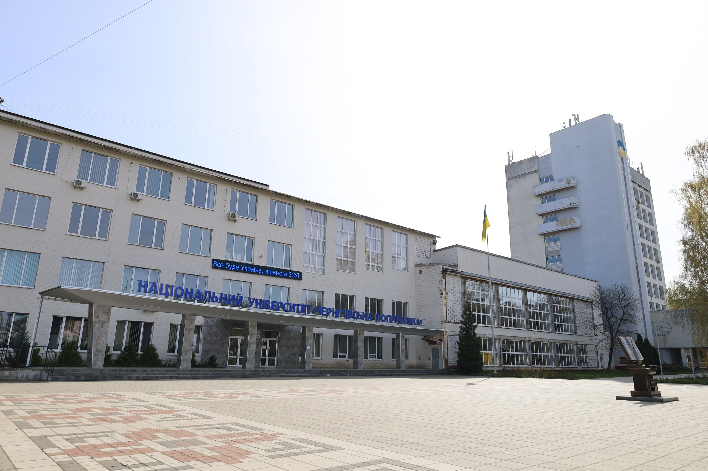
INVITATION

X International Scientific and Practical Conference «Accounting, Taxation, Analysis, and Auditing: Current Status, Challenges, and Development Prospects»
November 25, 2024, Chernihiv
Dear colleagues!
We inform you about the X International Scientific and Practical Conference, which will be held on November 25, 2024, at the National University 'Chernihiv Polytechnic «Accounting, Taxation, Analysis, and Auditing: Current Status, Challenges, and Development Prospects" (remote format). Scientists, faculty members of higher education institutions, doctoral candidates, practitioners, and higher education students are invited to participate in the conference. The purpose of the event is to exchange experiences in scientific research on the issues of accounting, taxation, analysis, and auditing.
CONFERENCE TOPICS:
- National and International Experience and Directions for the Development of Accounting as a Science and Practical Activity.
- Accounting and Analytical Support for Enterprise Reporting as a Basis for Management Decision-Making at Micro and Macro Levels.
- Economic Analysis of Enterprise Activities: Current State and Development Prospects.
- International and National Experience in the Organization, Functioning, and Development of Auditing.
- Accounting and Analytical Support for Enterprise Economic Security.
- Taxation of Enterprise Activities: Problems and Development Prospects.
- Information Systems and Technologies in the Accounting and Analytical Support System for Management Decision-Making in Accounting, Analysis, Auditing, and Taxation.
- Statistics and Econometric Methods and Models in Economics.
- Quality of Higher Education: Present and Future.
- Post-War Reconstruction of Ukraine’s Economy on the Principles of Sustainability.
- Economics of Natural Resource Management and Environmental Protection.
- Ukraine-EU Relations: Challenges, Achievements, and Prospects.

VENUE OF THE CONFERENCE
Chernihiv Polytechnic National University. Address: 14035, Chernihiv, Shevchenko St., 95.
Languages of the conference: Ukrainian, Polish, English.
Requirements for Formatting Abstracts of Reports
Volume: up to 2 pages of A4 format text.
Font: Times New Roman, 12-point.
Line spacing: single.
Width alignment
Page parameters: paragraph – 1 cm; margins – 2 cm on all sides.
The list of references is provided at the end of the abstracts with mandatory citations in the text in square brackets.
The following must be included in the abstracts: UDC, surname, initials, position of the author, place of work (study), title of the abstract, keywords. For higher education students and doctoral candidates, the full name of the scientific supervisor, their place of work, and position must also be specified.
Authors are encouraged to write a brief summary of 3-5 lines at the end of the abstract. All materials will be posted on the website of the National University 'Chernihiv Polytechnic'.

An example of a thesis statement.
UDC 657
O.O. Sydorenko, Ph.D. (Econ.), Associate Professor, Department of Economics, Accounting, and Taxation
Chernihiv Polytechnic National University, Chernihiv, Ukraine

PROBLEMS OF ACCOUNTING FOR PROVISIONS AND WAYS TO SOLVE THEM

Keywords: accounting, provisions, write-off, reduction, reversal.
In the process of conducting business activities, entities incur liabilities. One type of liability, according to the National Accounting Standard (NAS) 11 'Liabilities,' is provisions.

List of References: 1. Len' V.S., Hlyvenko V.V. Accounting in Ukraine: Fundamentals and Practice. Textbook. Kyiv: Center for Educational Literature, 2008. 608 pages.
Abstract. The work investigates...

CONFERENCE CALENDAR

By November 15, 2024 – acceptance of registration forms and materials for participation in the conference.

November 25, 2024 – conference holding.

Authors should send the registration form, abstracts, and a copy of the payment receipt to the organizing committee's email address no later than November 15, 2024 (subject of the email: Conference)): aleksalekseevih@stu.cn.ua
Examples of File Names: Dubovik_teza; Dubovik_karta; Dubovik_oplata. File Format: doc.

CONFERENCE MATERIALS
The collection of abstracts of the conference materials and the participant's certificate in electronic format (PDF format) will be sent to the email address provided in the registration form.

PARTICIPATION FEE
Registration fee of a participant, both from Ukraine and abroad: 120 UAH.
Payment Details: Chernihiv Polytechnic National University
Code 05460798 Current Account
UA 428201720313201001201006996 in DKSU s. Kyiv MFO 820172. Purpose of payment: For participation in conference Name Surname.
One author may submit no more than 2 abstracts, provided that payment is made for each of them.
Conference Coordinator:
Sydorenko Oleksandr Ph.D. (Econ.), Associate Professor, tel. +38 097-440-75-53.

We look forward to your interest and cooperation!
Sincerely, the Organizing Committee.

